Report
for
Auto Garage Software

Version 1.0 Approved

Prepared by:
Eman Rafique
Aqsa Nayab
Bisma Shahzad
Noor ul Eman

Quaid-i-Azam University
May 5, 2026

3. Analysis Models

Activity Diagram:
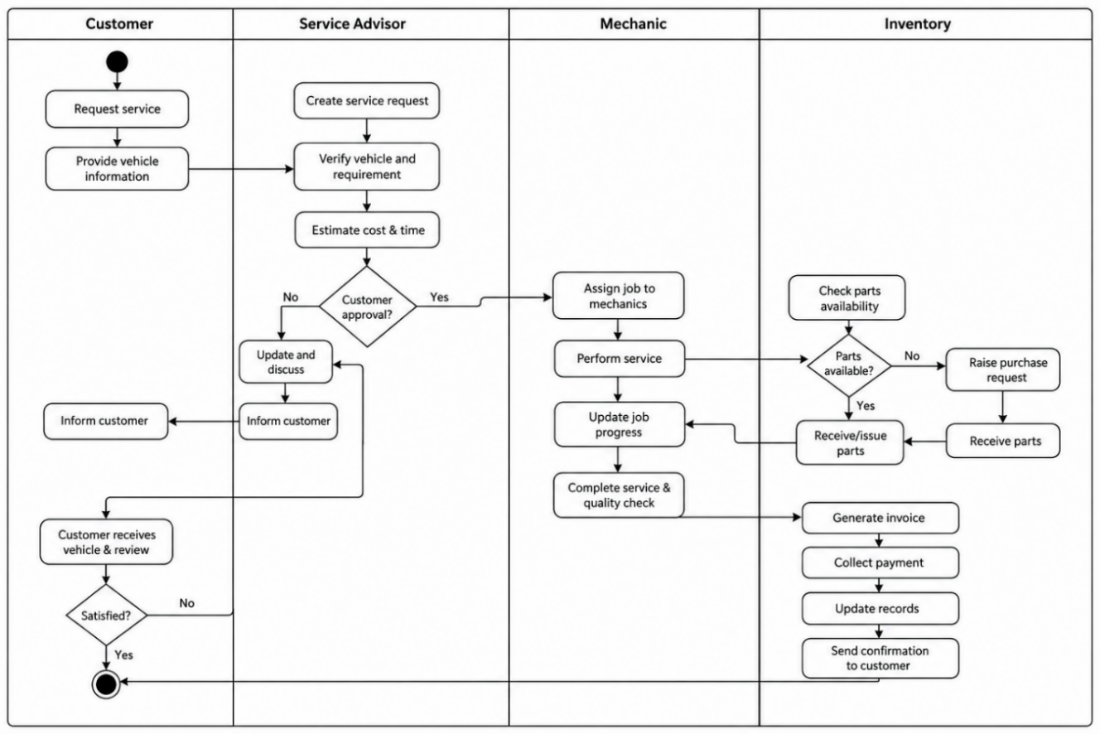
Description:

The activity diagram represents the working flow of the Auto Garage Management System. It explains how different tasks are performed from customer registration to service completion and invoice generation etc.
At first customer books appointment the service manager registers the customer and vehicle information if not registered in the system. A service request is then created and assigned to an available technician. The technician does the job and updates service status. After service completion the accountants generates invoice and records payment in finance module. At last the service history is stored in database for future reference

Data Flow Diagram:
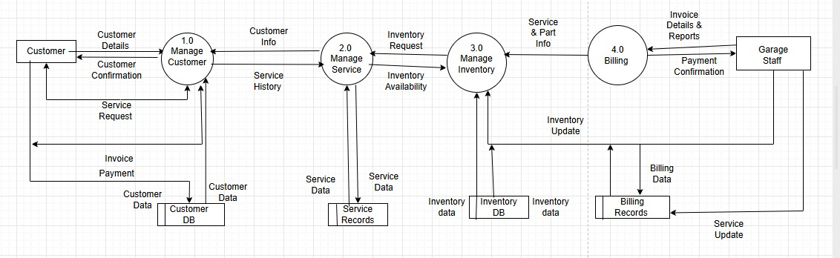
The data flow diagram illustrates how data moves throughout the system.

Level 0 DFD Description (Context Diagram ):

Customer provides vehicle and service request information to system and receive service updates , invoices , and repair details . Mechanics access assigned jobs , salary status , attendance etc. . Service Manager update service records , Finance department manages invoice generation , expenses details etc. . Inventory Management department manages inventory .

Level 1 DFD:

Data flow diagram divides the system into major functional processes , including service management , Inventory Management , Accounts Management etc. . It shows how data flows between these processes , data storage etc. .

Level 2 DFD Description:

This part provides more detailed view of individual processes within system. It breaks down processes into sub-processes such as customer registration, vehicle registration, service scheduling, repair record maintenance, spare parts management, invoice generation and payment processing. This level shows detailed movement of data required to perform operations within system.

System Sequence Diagram:

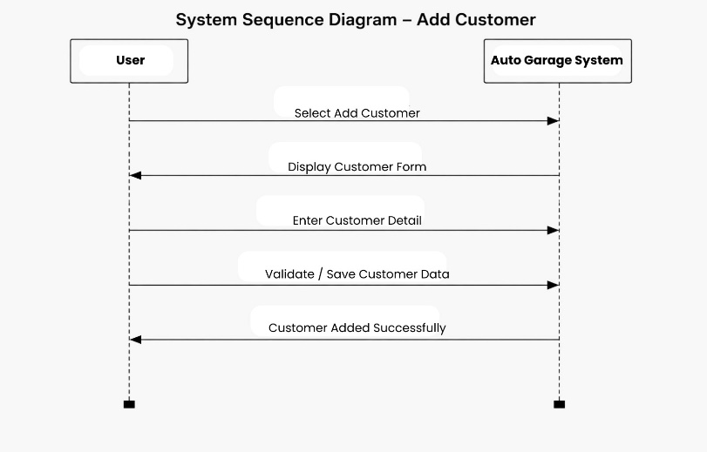
Description:
The system sequence diagram shows interaction between users and system.
Main Sequence:
- Customer requests vehicle service.
- Service Manager creates service record.
- System generates Service ID.
- Technician receives assigned task.
- Technician updates service progress.
- Inventory is updated if spare parts are used.
- System records completed service.
- Billing staff generates invoice.
- Customer makes payment.
- System stores transaction and updates records.

3.4 Use Case Diagram:

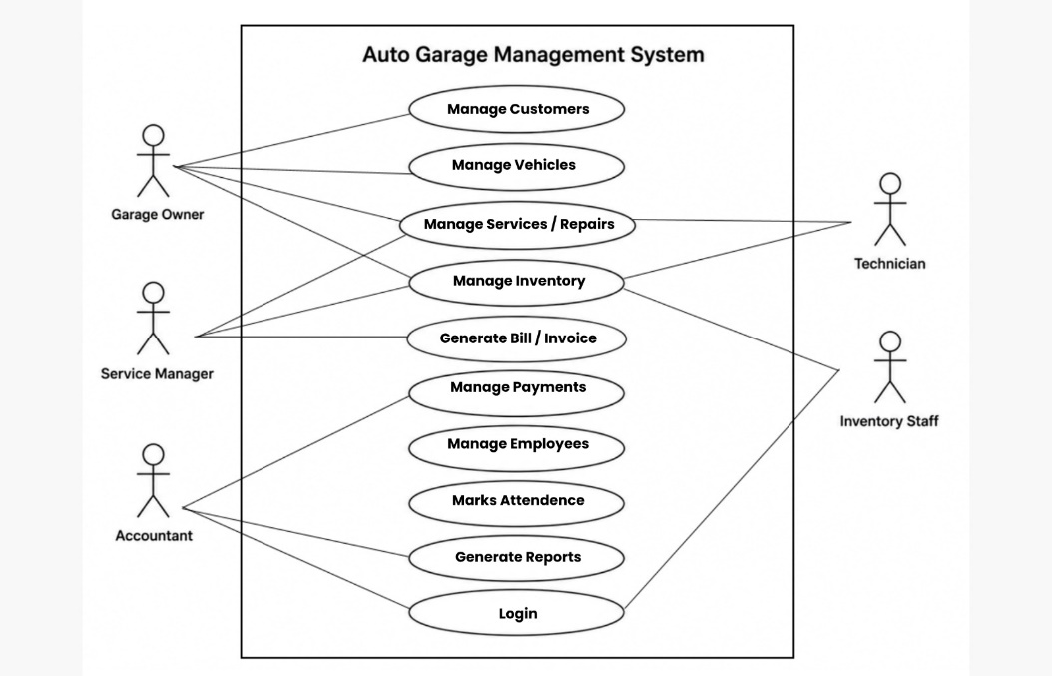

Description
The use case diagram shows major actors and their functionalities.
Actors
- Garage Owner
- Service Manager
- Technician
- Inventory Staff
- Accountant
- Customer

Main Use Cases
- Login
- Manage Customers
- Register Vehicle
- Create Service Request
- Assign Technician
- Update Repair Status
- Manage Inventory
- Generate Invoice
- Record Payment
- Manage Attendance
- Calculate Salary
- Generate Reports
- View Dashboard

Use Case Description :
Use Case 1: Login
Use Case Name: Login
Primary Actor: Garage Owner, Service Manager, Technician, Inventory Staff, Accountant
Description: Users log into the system using their username and password.
Preconditions:
User account exists.
User has valid login credentials.
Main Flow
User enters username and password.
System validates credentials.
System grants access based on user role.
User is redirected to the dashboard.
Postconditions
User successfully accesses the system.

Use Case 2: Customer Management
Primary Actor: Service Manager
Description: Manage customer and vehicle information.
Preconditions:
User is logged in.
Main Flow:
User selects Customer Management.
User enters customer and vehicle details.
System stores information.
User can search, update, or view records.
Postconditions:
Customer information is stored in the database.

Use Case 3: Vehicle Service Management
Primary Actor: Service Manager, Technician
Description: Manage vehicle service requests and repair progress.
Preconditions:
Customer and vehicle records exist.
Main Flow:
Service manager creates a service request.
System generates a service ID.
Technician is assigned to the task.
Technician updates service status.
System records progress.
Postconditions:
Service information is updated successfully.

Use Case 4: Inventory Management
Primary Actor: Inventory Staff
Description: Manage spare parts inventory.
Preconditions:
User is logged in.
Main Flow:
User adds or updates spare parts.
System updates stock records.
System generates low-stock alerts when necessary.
Postconditions:
Inventory records remain updated.

Use Case 5: Billing and Payment
Primary Actor: Accountant
Description: Generate invoices and record payments.
Preconditions:
Vehicle service is completed.
Main Flow:
Accountant generates invoice.
System calculates total amount.
Payment information is entered.
System stores payment record.
Postconditions:
Invoice and payment details are saved.

Use Case 6: Attendance and Payroll Management
Primary Actor: Employee, Garage Owner
Description: Track attendance and calculate salaries.
Preconditions:
Employee account exists.
Main Flow:
Employee checks in.
System records attendance.
Employee checks out.
System calculates working hours.
Salary is calculated based on working hours.
Postconditions:
Attendance and payroll records are updated.

Use Case 7: Reporting
Primary Actor
Garage Owner
Description: Generate business reports and dashboard summaries.
Preconditions
System contains operational data.
Main Flow
User opens dashboard.
System generates reports.
User views or prints reports.
Postconditions
Business performance reports are displayed.

